Giovanni Acireale

Assignment #5

package assignment5;

import java.util.Scanner;

import java.io.File;

import java.io.FileNotFoundException;

public class assignment5

{

//define the main method

public static void main(String[] args)

{

//create a scanner object

Scanner sc = new Scanner(System.in);

//prompt and in the year

System.out.println("Enter the year: ");

String year = sc.next();

//prompt and in the gender

System.out.println("Enter the gender (M or F): ");

String gender = sc.next();

//prompt and in the name

System.out.println("Enter the name: ");

String name = sc.next();

//close the scanner object

sc.close();

//create a file object and open the input file

File file = new File("babynamesranking" + year + ".txt");

/\*

if (file.exists())

{

System.out.println("File name: " + file.getName());

System.out.println("Absolute path: " + file.getAbsolutePath());

System.out.println("Writeable: " + file.canWrite());

System.out.println("Readable " + file.canRead());

System.out.println("File size in bytes " + file.length());

}

else

{

System.out.println("The file does not exist.");

}

\*/

//if file does not open properly, then exit

if (!file.exists())

{

System.out.println("No record for " + year);

System.exit(1);

}

int rank = 0;

try

{

//create a scanner for file

Scanner in = new Scanner(file);

//read the input text file

while (in.hasNext())

{

//read the line

String line = in.nextLine();

//split the line with each tab in an array

String[] array = line.split("\t");

//if gender = M and array[1] == name, change rank to array[0]

if (gender.equalsIgnoreCase("M") && array[1].contentEquals(name))

rank = Integer.valueOf(array[0]);

//if gender = F and array[3] == name, change rank to array[0]

else if (gender.equalsIgnoreCase("F") && array[3].contentEquals(name))

rank = Integer.valueOf(array[0]);

}

in.close();

}

//catch the exception

catch (FileNotFoundException e)

{

e.printStackTrace();

}

//if the rank is 0, the name doesn't exist

if (rank == 0)

{

System.out.println("The name " + name + " was not found in year " + year);

}

else

{

//Correct output

System.out.println(name + " is ranked #" + rank + " in year " + year);

}

}

}

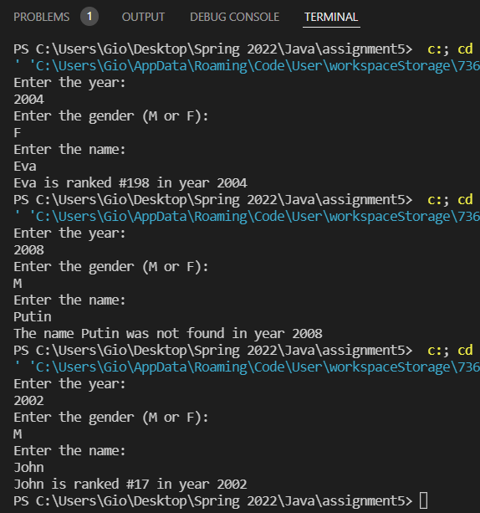

I only realized the provided zip file after copying the data manually, the only change I would need to make to make it functional with the provided files would to change the capitalization of b in line 31.